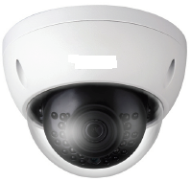
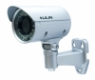
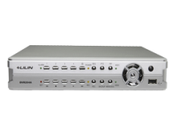
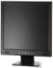
Indoor Camera Outdoor Camera DVR / NVR Monitor

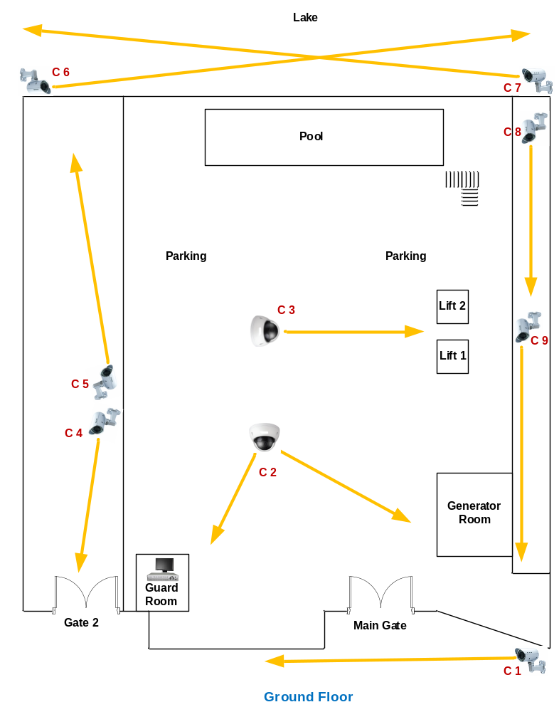
Customer Name | Wind Crest Apartment
Drawing Title | CCTV – Ground Floor
Issue No | RE/TE
Issue Date | 10/3/2019
Revision No
Revision Date
Created By | Ajith Fernando
Approved By

